

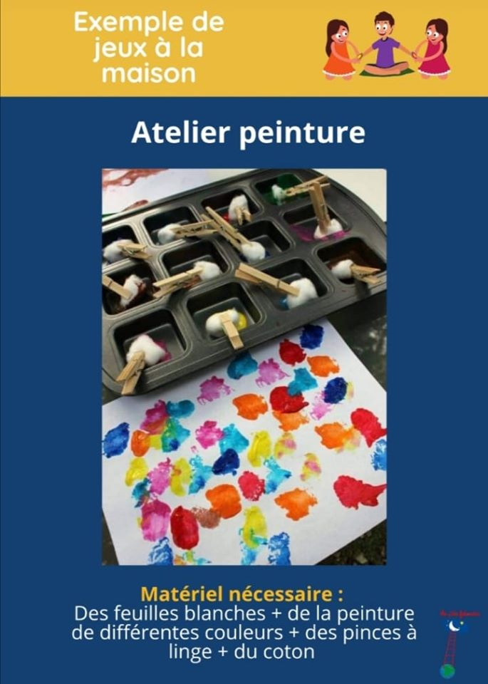

[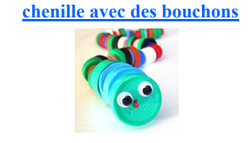](http://www.petitestetes.com/bricolage/chenille-avec-des-bouchons.html)[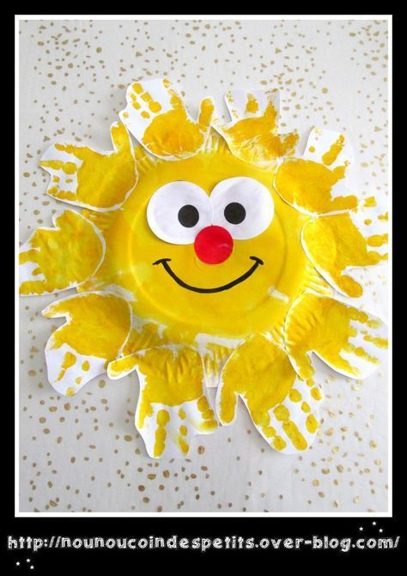](https://babyzimmer.miningbtc.me/un-grand-soleil-de-printemps-avec-des-empreintes-de-main-le-blog-de-nounoucoindespetits/) 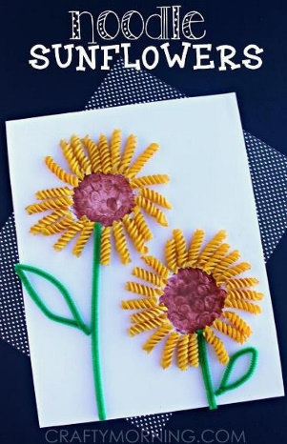

[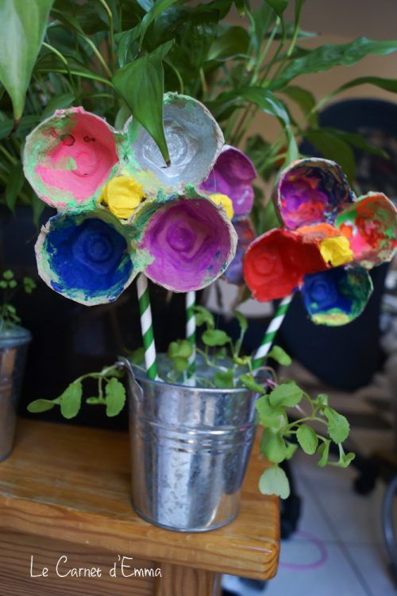](https://lecarnetdemma.fr/2016/04/29/fleurs-boite-a-oeufs/) [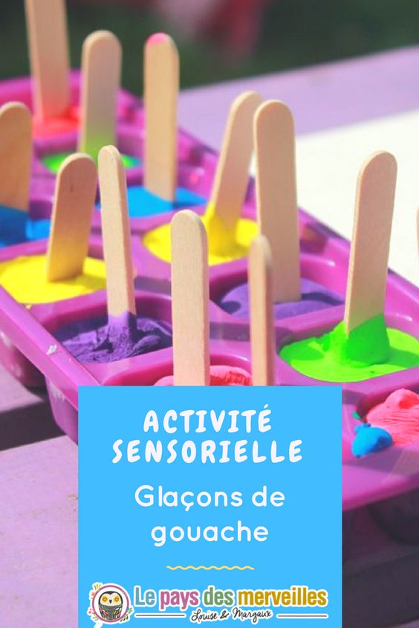](https://www.lepaysdesmerveilles.com/peindre-glacons-gouache-activite-rafraichissante-coloree-ete.html) [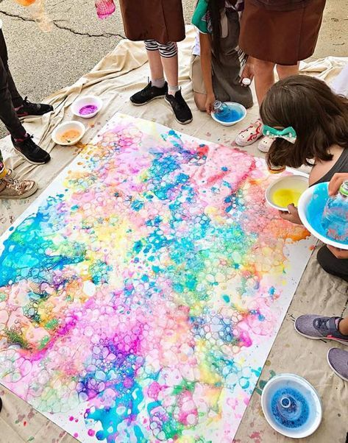](https://www.trucsetbricolages.com/brico-enfant/voici-la-recette-pour-faire-de-belles-bulles-colorees-sur-une-toile-ou-du-papier)

[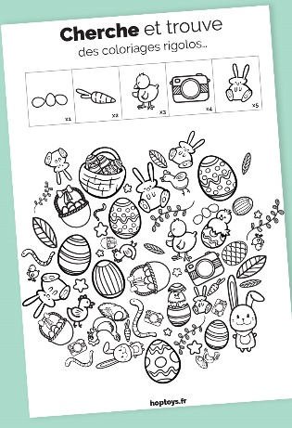](https://www.bloghoptoys.fr/cherche-et-trouve-avec-des-coloriages-rigolos?fbclid=IwAR0xhbHSzjk8z3tqePVVS2SifvAiqBYB0mJMiOAmL4y2ujWDzqkVKJ6eoNo) [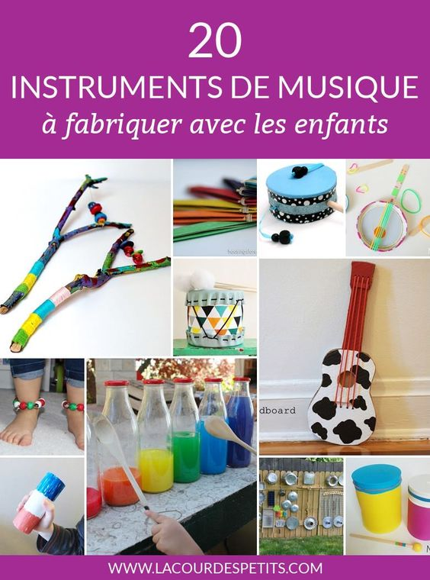](https://www.lacourdespetits.com/instruments-musique-fabriquer/)



[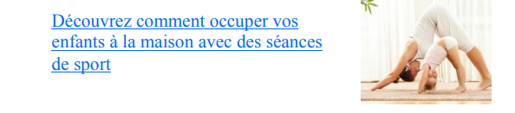](https://www.teteamodeler.com/activit%C3%A9s/confinement/TOP-10-des-videos-pour-faire-du-sport-a-la-maison-avec-les-enfants?)

[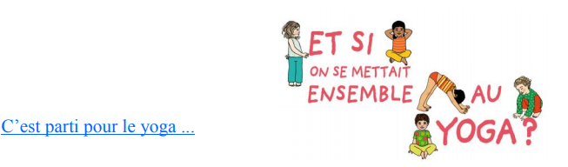](https://www.youtube.com/watch?v=Sku3BeewbWA)

[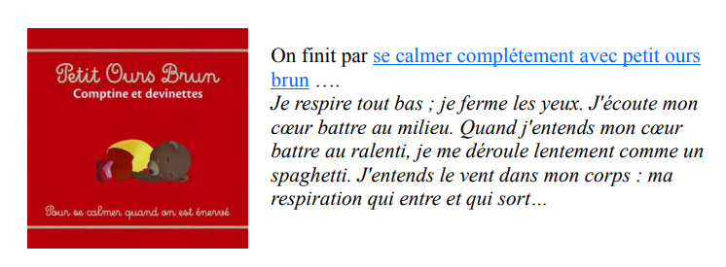](https://www.lumni.fr/video/petit-ours-brun-comptine-pour-se-calmer-quand-on-est-enerve#containerType=serie&containerSlug=petit-ours-brun)



[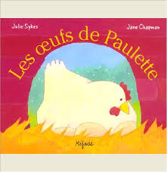](https://www.youtube.com/watch?v=zXP6T7sF3oA&feature=youtu.be) [](https://vimeo.com/400907428) [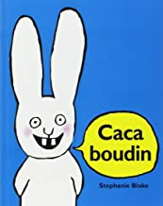](https://vimeo.com/399883460)

[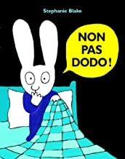](https://vimeo.com/399883529) [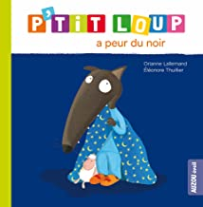](https://www.youtube.com/watch?v=sKaTwGfhl1E) [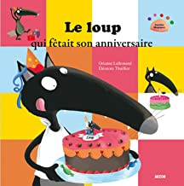](https://www.youtube.com/watch?v=8js_Slcxn_I)

[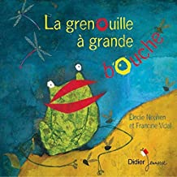](https://www.youtube.com/watch?v=FZGHtLw4ZPY&feature=youtu.be) [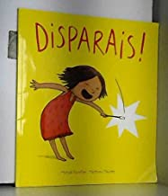](https://vimeo.com/402585707)